1. INNER JOIN
Aim
To retrieve the supplier ID, supplier name, and order date using the INNER JOIN operation.
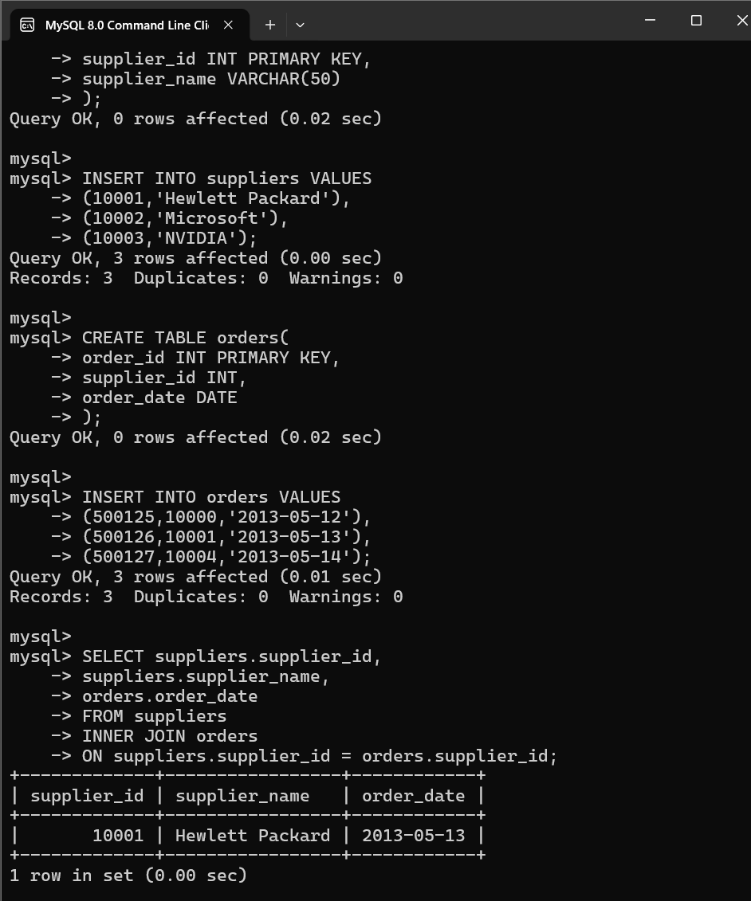Output
supplier_id | supplier_name | order_date
10001 | Hewlett Packard | 2013-05-13
2. LEFT JOIN
Aim
To retrieve all suppliers and their corresponding order dates using LEFT JOIN.
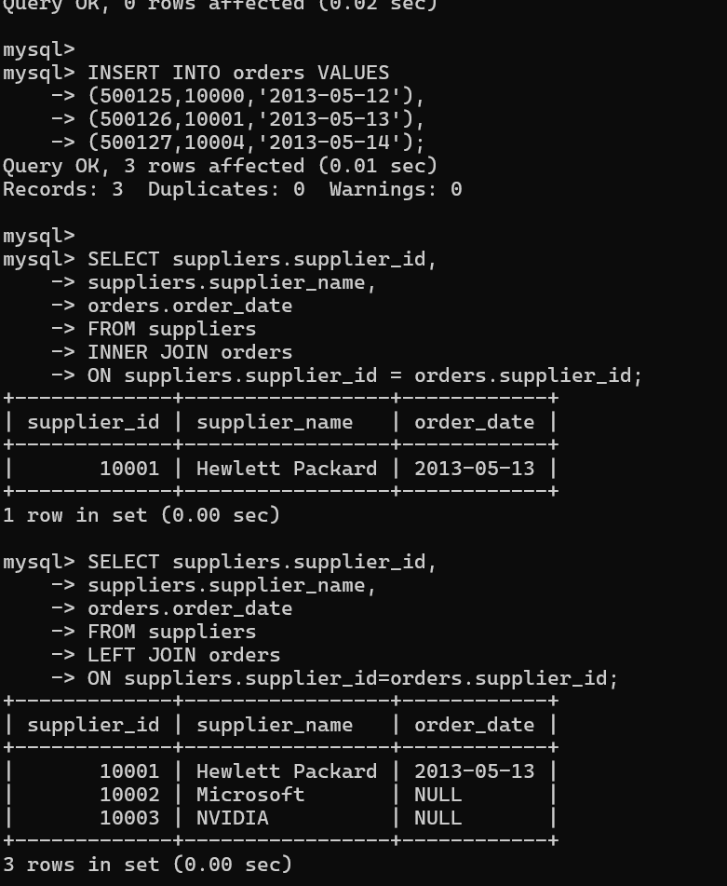
Output
supplier_id | supplier_name | order_date
10001 | Hewlett Packard | 2013-05-13
10002 | Microsoft | NULL
10003 | NVIDIA | NULL
3. JDBC Program
Aim
To connect MySQL using JDBC and create the TICKETBOOKING table in the examDB database.
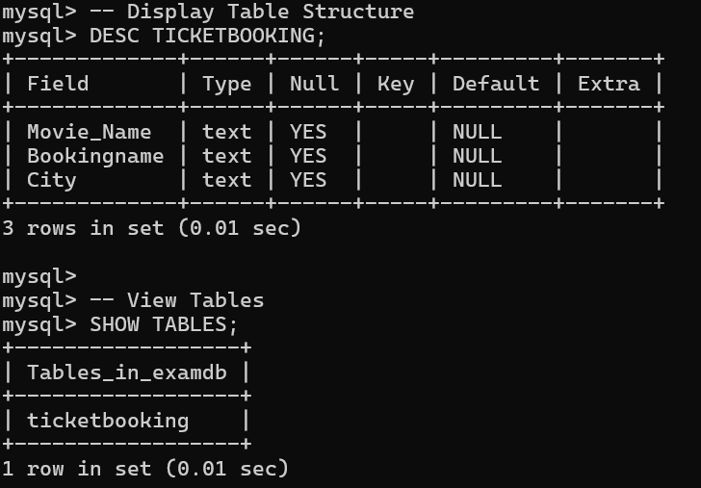
4. DML Statements (Book Publishing Company)
Aim
To perform SELECT and INSERT operations using DML statements.
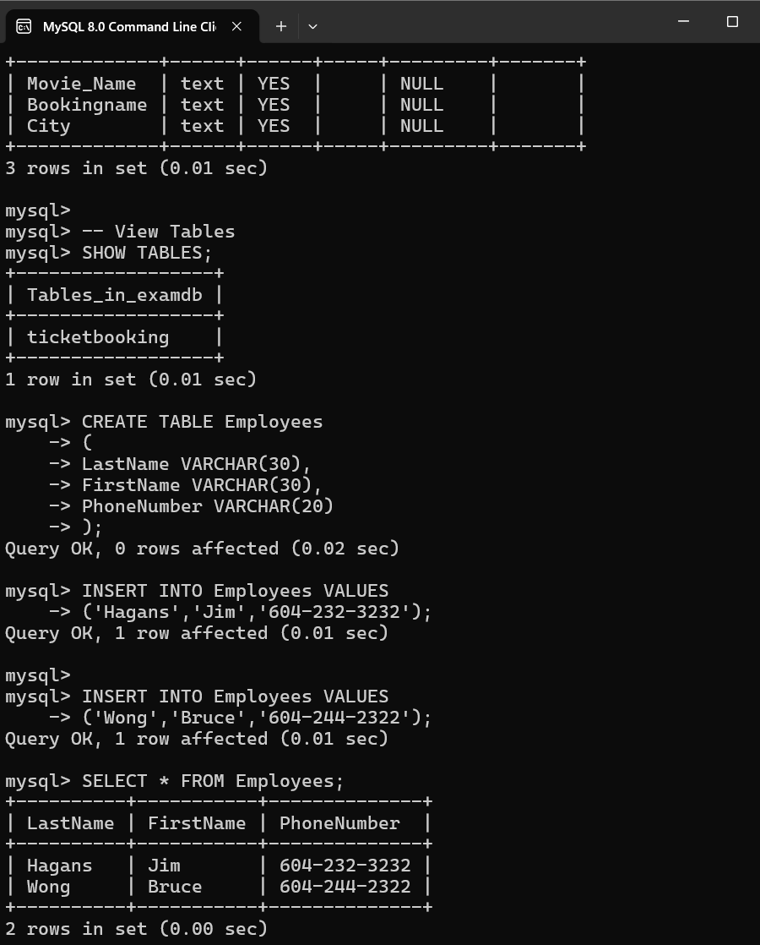
LastName | FirstName | PhoneNumber
Hagans | Jim | 604-232-3232
Wong | Bruce | 604-244-2322

